**TEAMDUTY Web-application**

Test Plan

**By**

Mr. Manuchet Manoi 542115049

Mr. Saknarong Noipaksa 542115061

Department of Software Engineering

College of Arts, Media and Technology

Chiang Mai University

**Project Advisor**

______________________________________

**Aj. Jayakrit Hirisajja**

**Document History**

|  |  |  |  |  |  |  |  |
| --- | --- | --- | --- | --- | --- | --- | --- |
| **Document Name** | **Version** | **Status** | **Date** | **Viewable** | **Reviewer** | | **Responsible** |
| **Documents** | | | | | | | |
| TEAMDUTY - Web application - SRS v 0.1.docx | **Add Chapter 1**  - Objective  - Intended Audience and Reading Suggestions  - Project Scope | Draft | 01 May 2014 | MM,  SN,JH | | MM,  SN | MM,  SN |
| TEAMDUTY - Web application - SRS v 0.1.docx | **Add Chapter 2**  **-** Product Perspective  - Product Features  - User Classes and Characteristics  - Operation Environment  - Design and Implementation Constraints  **Add Chapter 3**  **-**User requirement  **Add Chapter 5**  -Traceability Record | Draft | 01 May 2014 | MM,  SN,JH | | MM,  SN | MM,  SN |
| TEAMDUTY - Web application - SRS v 0.2.docx | **Adjust Chapter 3**  -Approve URS & SRS | Draft | 06 May 2014 | MM,  SN,JH | | MM,  SN | MM,  SN |
| TEAMDUTY - Web application - SRS v 0.3.docx | **Add Chapter 4**  -Software Requirement Specification  -Use case Description & Activity Diagram  -Quality Requirement |  |  |  | |  |  |

**\*MM = Manuchet Manoi**

**\*SN = Saknarong Noipaksa**

**\*JH = Jayakrit Hirisajja**

**Table of Contents**

# Chapter One | Introduction

# Chapter Two | TestRecord

**Class HomeController**

**Controller Unit Test Case 1**# Index()

*TestTool :* Visual Studio 2012 (Unittest)

*TestMethod :*

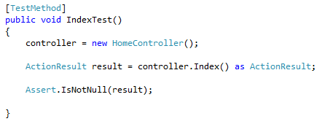

*TestResult :*

|  |  |  |  |
| --- | --- | --- | --- |
| ID | **Expected Result** | Actual Result | Pass/Fail |
| 1 | Pass | Pass | Pass |
| 2 | Fail | Fail | Pass |

*TestReferrence :*

**Class AccountController**

**Controller Unit Test Case 2**# Create()

*TestTool :* Visual Studio 2012 (Unittest)

*TestMethod :*

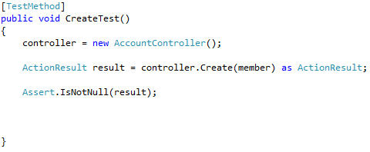

*TestResult :*

|  |  |  |  |
| --- | --- | --- | --- |
| ID | **Expected Result** | Actual Result | Pass/Fail |
| 1 | Pass | Pass | Pass |
| 2 | Fail | Fail | Pass |

*TestReferrence :*

**This TestCase Create Stub member to use in this Unittest case

public MyApplication.Member member { get; set; }

**Controller Unit Test Case 3**# ConfirmRegister()

*TestTool :* Visual Studio 2012 (Unittest)

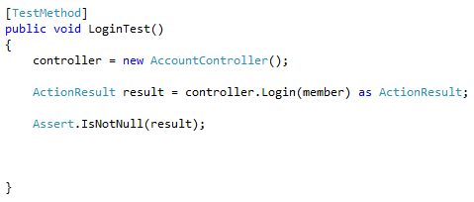*TestMethod :*

*TestResult :*

|  |  |  |  |
| --- | --- | --- | --- |
| ID | **Expected Result** | Actual Result | Pass/Fail |
| 1 | Pass | Pass | Pass |
| 2 | Fail | Fail | Pass |

*TestReferrence :*

**This TestCase Create Stub member to use in this Unittest case

public MyApplication.Member member { get; set; }